Experiment No :- 05

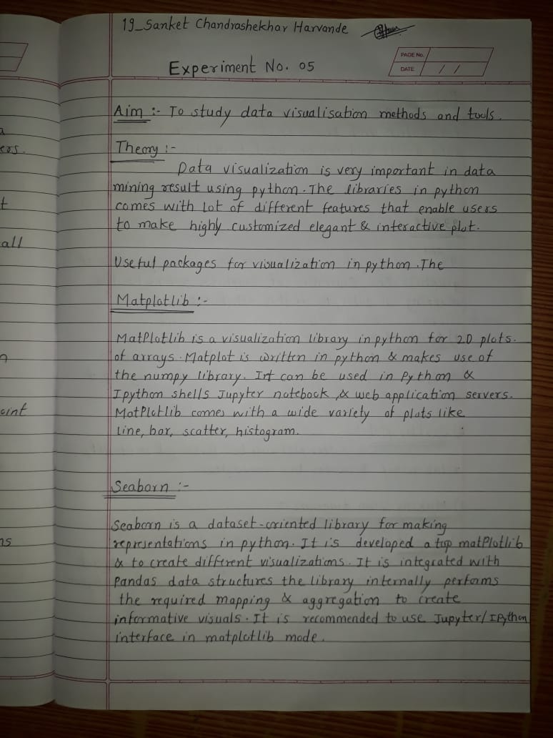

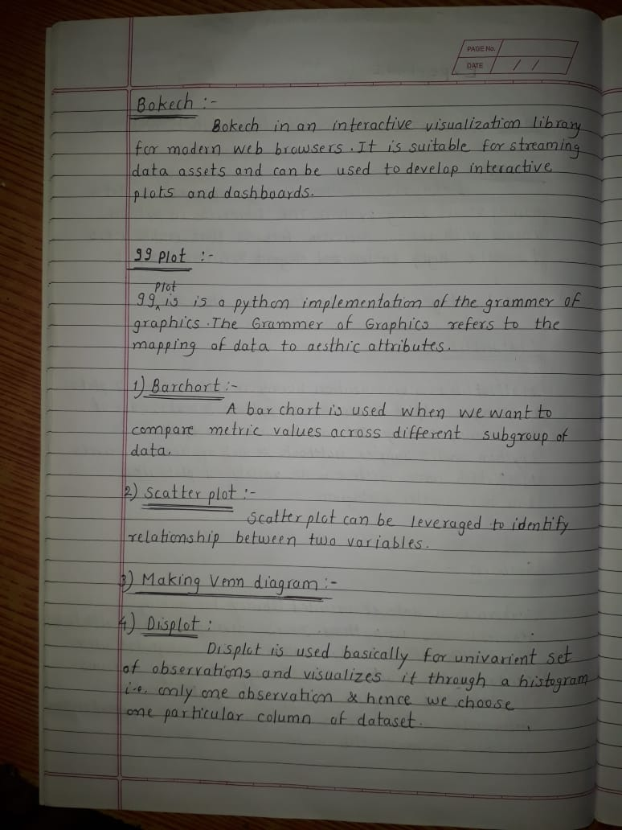

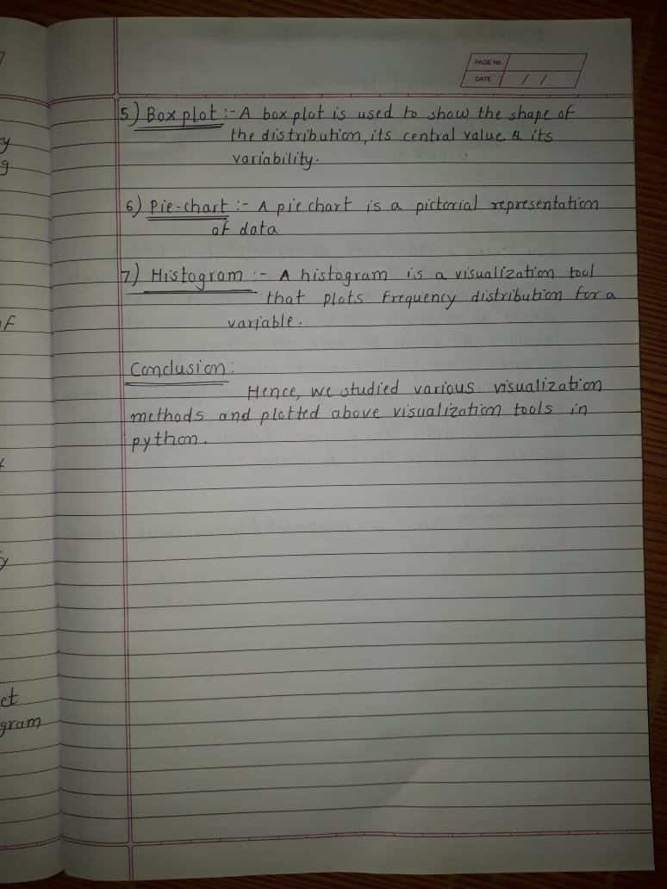

1. **Bar chart**

import seaborn as sns

import matplotlib.pyplot as plt import pandas as pd

import numpy as np #Creating the dataset

df = sns.load_dataset(&#39;titanic&#39;) df_pivot = pd.pivot_table(df,

values=&quot;fare&quot;,index=&quot;who&quot;,columns=&quot;clas s&quot;,

aggfunc=np.mean)

#Creating a grouped bar chart

ax = df_pivot.plot(kind=&quot;bar&quot;,alpha=0.5) #Adding the aesthetics

plt.title(&#39;GIT COMPUTER Data ANalysis&#39;) plt.xlabel(&#39;X axis title&#39;) plt.ylabel(&#39;Y axis title&#39;)

# Show the plot plt.show()

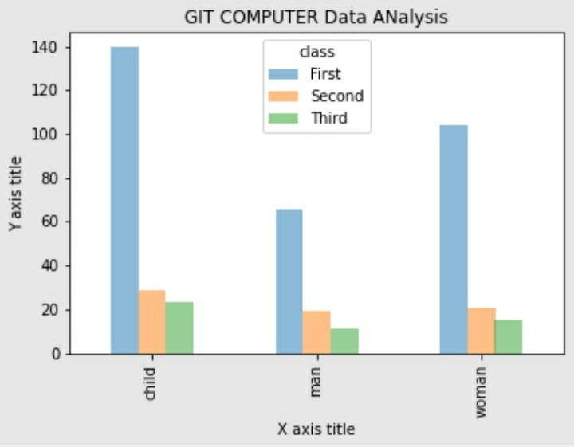

**#Bar chart**

import matplotlib.pyplot as plt import pandas as pd

import seaborn as sns import numpy as np

# importing the required library

# read a tips.csv file from seaborn libraray df = sns.load_dataset(&#39;tips&#39;)

# count plot on two categorical variable

sns.countplot(x =&#39;sex&#39;, hue = &quot;smoker&quot;, data = df)

# Show the plot plt.show()

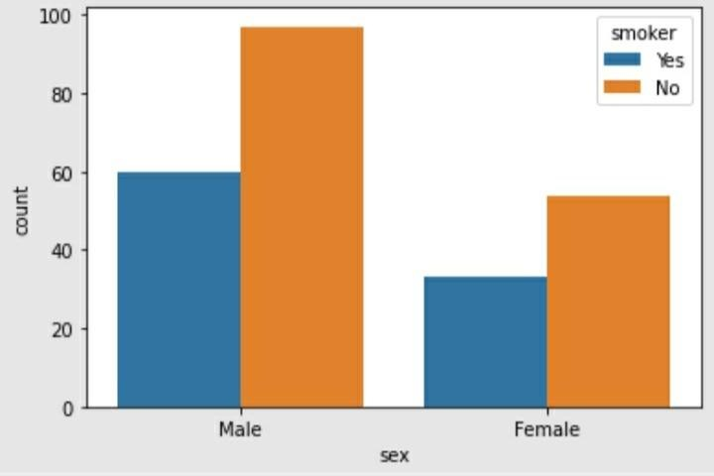

**#Horizontal BAR chart** import matplotlib.pyplot as plt import seaborn as sns

# read a tips.csv file from seaborn libraray df = sns.load_dataset('tips')

# count plot along y axis

sns.countplot(y ='sex', hue = "smoker", data = df) # Show the plot

plt.show()

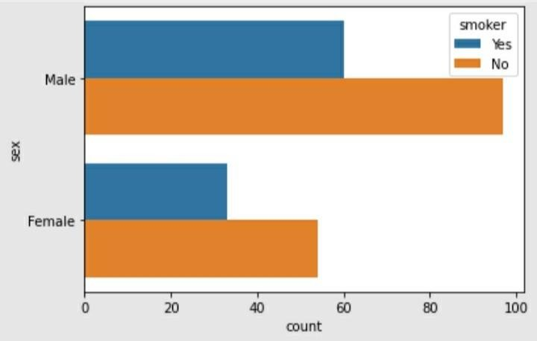

1. Scatter Plot

import seaborn as sns

import matplotlib.pyplot as plt import pandas as pd

import numpy as np #Creating the dataset

df = sns.load_dataset("tips") #Creating the scatter plot

plt.scatter(df['total_bill'],df['tip'],alpha=0.5 ) #Adding the aesthetics

plt.title('Chart title') plt.xlabel('X axis title') plt.ylabel('Y axis title') #Show the plot plt.show()

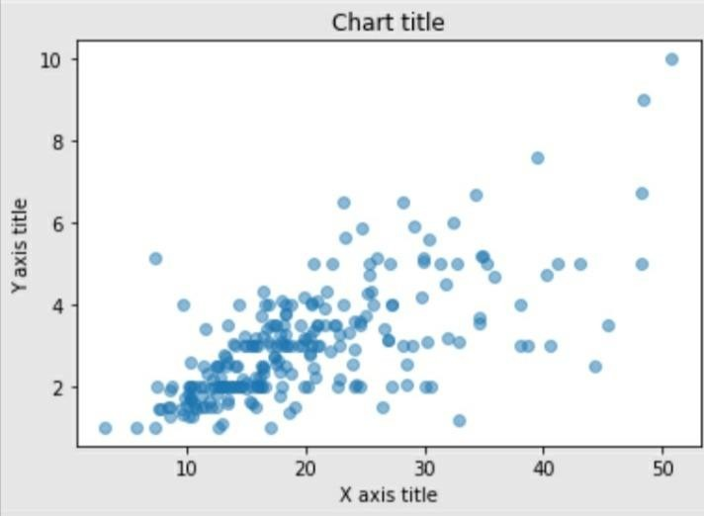

* 1. **3)** Making venn diagram

from matplotlib_venn import venn3 import matplotlib.pyplot as plt venn3(subsets = (10, 8, 22, 6,9,4,2)) plt.show()

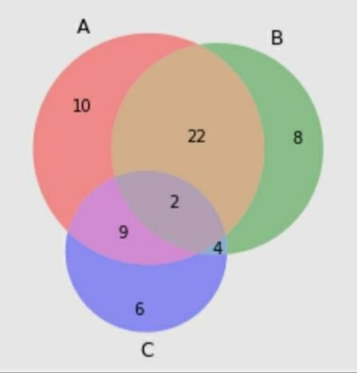

**4**) Displot

# importing packages import seaborn as sns

import matplotlib.pyplot as plt

# loading dataset

data = sns.load_dataset("iris") sns.distplot(data['sepal_width'])

plt.show()

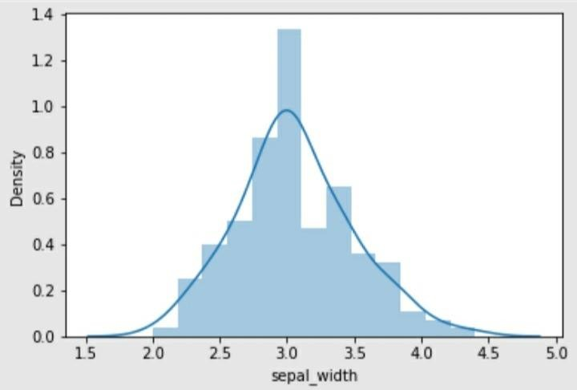

1. Box plot

import seaborn as sns

import matplotlib.pyplot as plt #Reading the dataset

bill_dataframe = sns.load_dataset("tips") #Creating boxplots

ax = sns.boxplot(x="day", y="total_bill", hue="smoker", data=bill_dataframe, palette="Set3") #Adding the aesthetics

plt.title('Chart title') plt.xlabel('X axis title') plt.ylabel('Y axis title') # Show the plot plt.show()

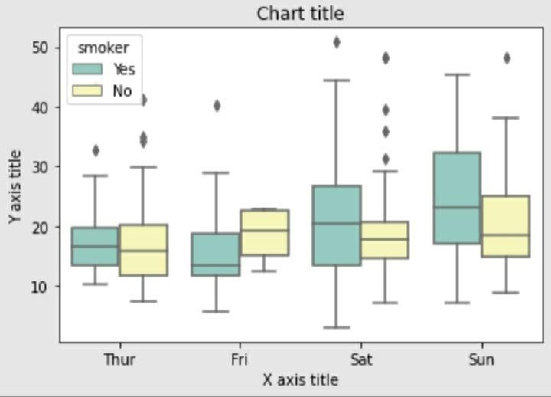

1. Pie-chart

# importing packages import seaborn as sns

import matplotlib.pyplot as plt #Creating the dataset

cars = ['AUDI', 'BMW', 'NISSAN',

'TESLA', 'HYUNDAI', 'HONDA'] data = [10, 15, 15, 14, 16, 25]

#Creating the pie chart

plt.pie(data, labels = cars,colors = ['GREEN','BLUE','#B0E0E6','#7B68EE','#483D8B','red']) #Adding the aesthetics

plt.title('CAR Analysis Report') #Show the plot

plt.show()

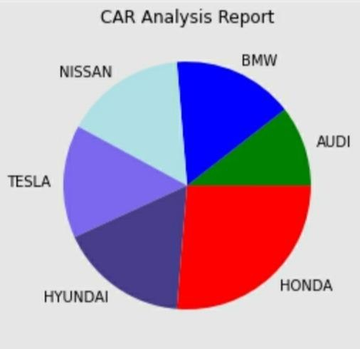

5)Histogram:-

import matplotlib.pyplot as plt

data = [87, 53, 66, 61, 67, 68, 62, 110,

104, 61, 111, 123, 117, 119, 116,

104, 92, 111, 90, 103, 81, 80, 101,

51, 79, 107, 110, 129, 145, 128,

132, 135, 131, 126, 139, 110]

binwidth = 6

plt.hist(data, bins=range(min(data), max(data) + binwidth, binwidth), edgecolor="yellow", color="brown")

plt.show()

